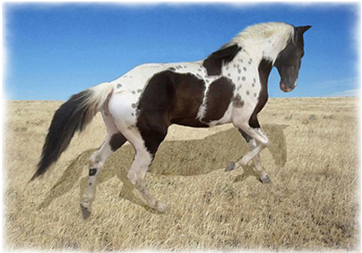
Transported Semen Contract
For the stallion:
Sky High Ryder
TWHBEA # 20702796

Mare____________________Registry(ies) and Number(s)___________________________
Mare Owner(s) _____________________________________________________________
The stud fee of $300.00 must be received before any semen will be sent. In addition, before any semen will be sent, a fee of $225.00 for collecting, extending and sending the semen by Fedex. over-night must be received for each shipment, should additional shipments be necessary. A deposit of $400.00 on the Equitainer must received by the stallion owner for each shipment before any semen is sent. This deposit will be returned to the mare owner when the Equitainer is returned to the stallion owner. The Equitainer must be returned the next day by Fedex. over-night service. Additional shipments of semen will be sent under the conditions and costs detailed above if the mare is examined by a licensed veterinarian by sonogram and found to be barren at no less than 15 days from the date of last insemination, or by palpation and found to be barren at no less than 55 days from the date of last insemination. This is a one calendar yearcontract only.
Should the mare conceive but not produce a live spotted foal that stands and nurses, the mare owner shall be entitled to further shipments of semen under the conditions and costs detailed above, or live cover of the same mare if the stallion owner is notified in writing by a licensed veterinarian. If the mare owner chooses to breed using live cover, the mare must be sent to Skies R Blue Stables at the expense of the mare owner and the mare owner agree to pay $7.00 per day in mare care fees.
In the event the mare does not conceive or does conceive and not produce a live spotted foal that stands and nurses, and the stallion has died, been gelded, been sold, or has in any way become unfit for breeding, this contract becomes null and void and the mare owner shall be entitled to a refund of the stud fee.
In the event the mare does not conceive or does conceive and not produce a live spotted foal that stands and nurses and the mare has been sold, this contract becomes null and void. Death of the mare after conception but before foaling will render this contract null and void.
Should the mare be sent for live cover, the stallion owner agrees to hold the mare owner blameless, not liable and not responsible for any injury caused to the stallion by the mare during the breeding process. The mare will wear breeding hobbles.
The mare owner shall assume all responsibility for the condition of the mare, veterinary expenses for the mare and shall be responsible for determining the optimal time for sending semen. The mare owner shall inform the stallion owner at least 24 hours prior to time semen is to be collected and sent. Should the mare be sent for live cover, the mare owner shall bear all risk of death or injury to the mare or escape of the mare during the breeding and boarding process and agrees to hold the stallion owner, Skies R Blue Tennessee Walking Horse Stables and any person employed by or associated with Skies R Blue Tennessee Walking Horse Stables blameless, not liable and not responsible for any and all damage to, injury to, or loss of the mare associated with boarding and breeding.
For the purposes of this contract, a spotted foal is defined as a foal with one white mark above any hock, excluding the face.
The stallion owner shall reserve the right to refuse any mare.
Any mare left for 60 days after the last breeding will be considered abandoned and may be sold by Skies R Blue Tennessee Walking Horse Stables.
_________________________________________ ____________________________
Stallion Owner, Skies R Blue TWH Stables Mare Owner
date__________________ date__________________

