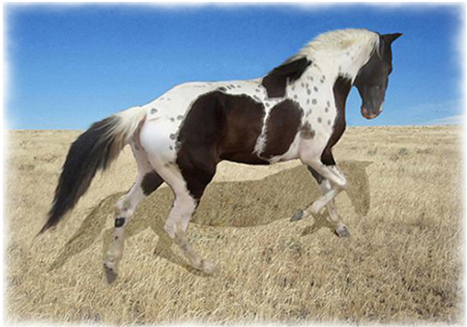
Breeding Contract for the stallion:
Sky High Ryder
TWHBEA 20702796

Mare____________________Registry(ies) and Number(s)___________________________
Mare Owner(s) _____________________________________________________________
Stud fee of $300.00 shall be paid by the mare owner at the time the mare arrives for breeding. A booking fee of $50.00, which will be subtracted from the stud fee, will reserve a breeding. Mare care at $6.00 per day, or $4.00 per day if the mare owner supplies the feed, shall be due before the mare leaves Skies R Blue Stables. The stallion owner agrees to allow free return privileges to the stallion by the same mare if the mare is examined by a licensed veterinarian by sonogram and found to be barren at no less than 16 days from the date of the last service, or by palpation and found to be barren at no less than 55 days from the date of last service, or if the mare comes back into heat on her next cycle. If, after a full breeding season, the mare fails to conceive, the stallion owner agrees to allow free return privileges to the stallion by the same mare or a substitute mare during the next breeding season. This is a one calendar year contract only.
For the purposes of this contract, a breeding season is defined as March through September of any calendar year.
Should the mare conceive but not produce a live foal that stands and nurses, the mare owner shall be entitled to free return privileges to the stallion by the same mare or a substitute mare during the same or the next breeding season, if the stallion owner is notified in writing by a licensed veterinarian.
In the event the mare does not conceive or does conceive and not produce a live foal that stands and nurses, and the stallion has died, been gelded, been sold, or has in any way become unfit for breeding, this contract becomes null and void and the mare owner shall be entitled to a refund of the stud fee in full.
In the event the mare does not conceive or does conceive and not produce a live foal that stands and nurses and the mare has been sold, this contract becomes null and void. Death of the mare after conception but before foaling will render this contract null and void.
The stallion owner agrees to hold the mare owner blameless, not liable and not responsible for any injury caused to the stallion by the mare during the breeding process. The mare may wear breeding hobbles.
The mare owner shall assume all responsibility for the condition of the mare, veterinary expenses for the mare and shall bear all risk of death or injury to the mare or escape of the mare during the breeding and boarding process and agrees to hold the stallion owner, Skies R Blue Stables and any person employed by or associated with Skies R Blue Stables blameless, not liable and not responsible for any and all damage to, injury to, or loss of the mare associated with boarding and breeding.
The stallion owner shall reserve the right to refuse any mare.
The mare owner will supply a 6 mo. Negative Coggins and a clean culture.
Any mare left for 60 days after the last breeding will be considered abandoned and may be sold by Skies R Blue Stables.

___________________________ ___________________________
Stallion Owner Mare Owner
date__________________ date__________________

